

QUALNET PROJECT

ELEC 6851: Introduction to Telecommunication Networks

Submitted by:

Adnaan Khan (40185329)

Mohammed Sohail (40187593)

**Abstract:**

The following project involves working of multiple subnetworks which are operating on different channels. The only connection between the subnetworks are the routers which can listen in between 2 channels. In each sub network there are 5 nodes operating in the same channel but cannot send or receive data directly to nodes in another sub network as their channel is different. For the project we used 4 sub networks and 3 routers to create connections between these sub networks. For the following project there are 2 scenarios. In scenario A, we created TCP and UDP traffic between 2 nodes which belong 2 different subnetworks and we measured the values found in Application, Transport and MAC layers. Also, it is required that the traffic generator must generate minimum of 500 packets. In scenario B, we are required to make an UDP connections in such a was that one of the 3 routers is required to work three times as normal creating a bottleneck router. Now, once we decide on a bottleneck router, we choose a UDP connection and change the mean packet interval and mark the changes at the router in average delay in transmission, UDP client throughput and UDP server throughput. The following scenario is also repeated with ‘fading’ as well and a comparison is performed.

**Project schematic (Scenario A):**

We created 4 sub networks.

Once connected, we allotted each sub network a channel frequency

Channel frequency [0] =2.4 GHz

Channel frequency [1] =2.5 GHz

Channel frequency [2] = 2.6 GHz

Channel frequency [3] =2.7 GHz

The routers interconnecting the sub networks are capable of listening to 2 frequencies.

The following figure 1 shows the structure of the network.

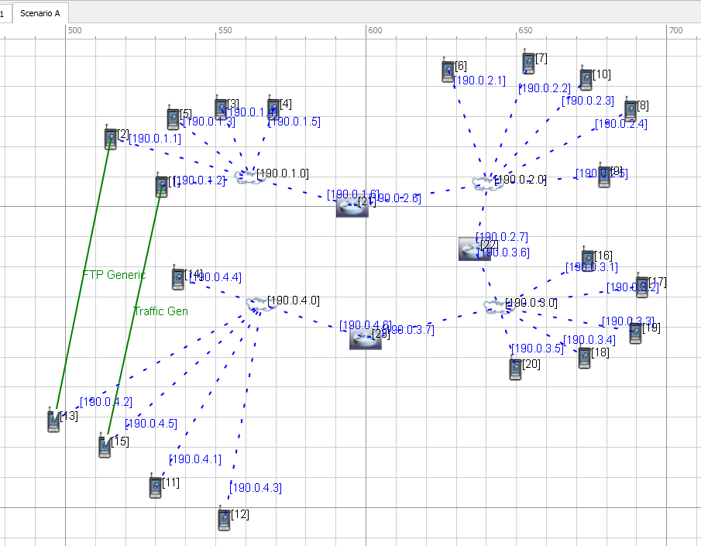

Figure 1. Schematic for Scenario A.

As we see in the collection of networks shown above, we created two traffic generators and connected [190.0.1.1][2] to [190.0.4.2][13] with FTP Generic (TCP traffic) and [190.0.1.2][1] to [190.0.4.5][15] with Traffic Generator (UDP traffic). average

The maximum transmission time is set to 600 seconds. The packet size is set to 2048 bytes.

The following are the node and the IP configurations

|  |  |  |
| --- | --- | --- |
| TCP Connection | from 190.0.1.2[1] | to 190.0.4.5[15] |
| FTP Connection | from 190.0.1.1[2] | to 190.0.4.2 |

The values for FTP generic and UDP are:

Traffic gen (UDP):

The following are values considered for the UDP connection

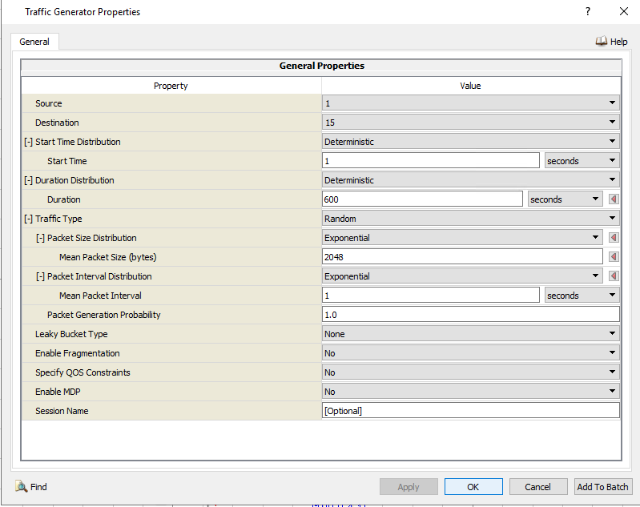

Figure 2

FTP generic (TCP):

The following are the values considered for the TCP connection

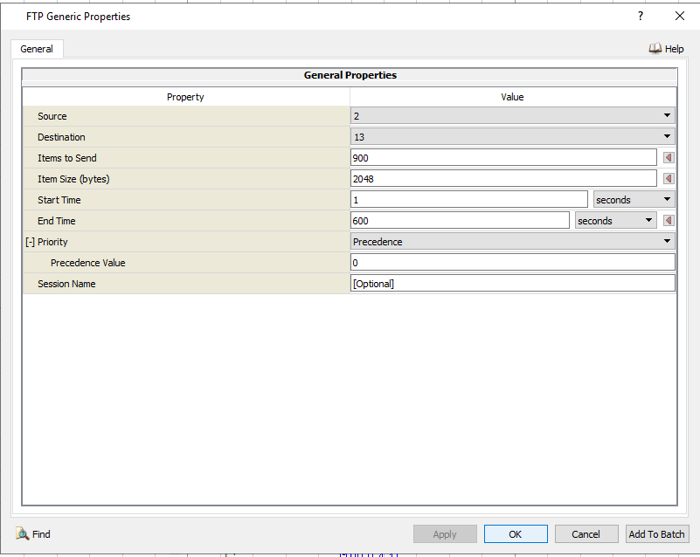

Figure 3

Scenario properties:

The following are the scenario properties for all the scenario A and B

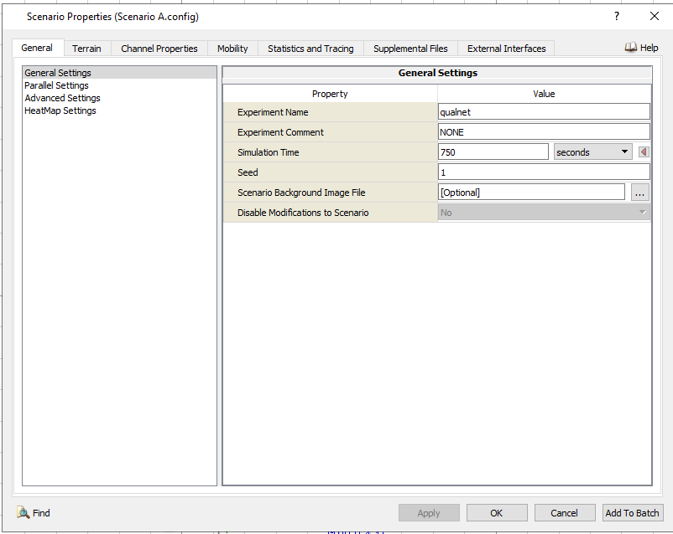

Figure 4

**Result:**

Application Layer:

The following are the values observed at the application layer

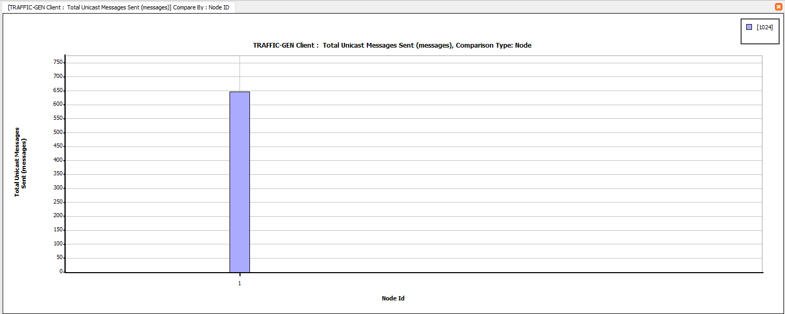

Figure 5. Traffic client data units sent UDP

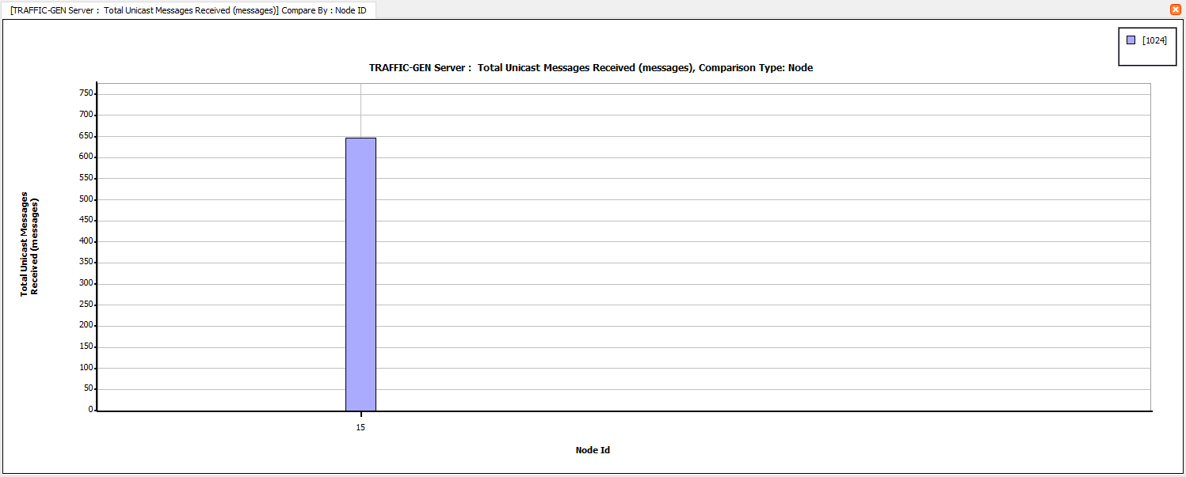

Figure 6. Data units received at UDP

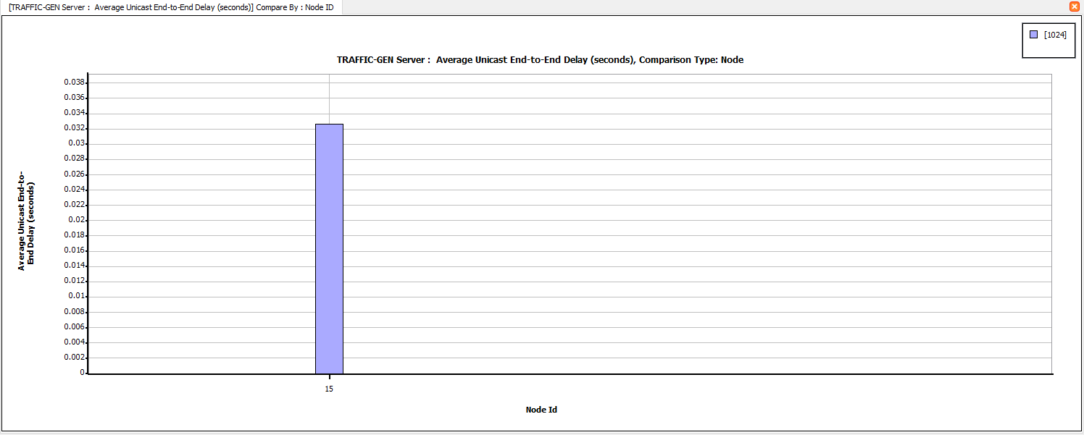

Figure 7. End to end delay at UDP

TCP:

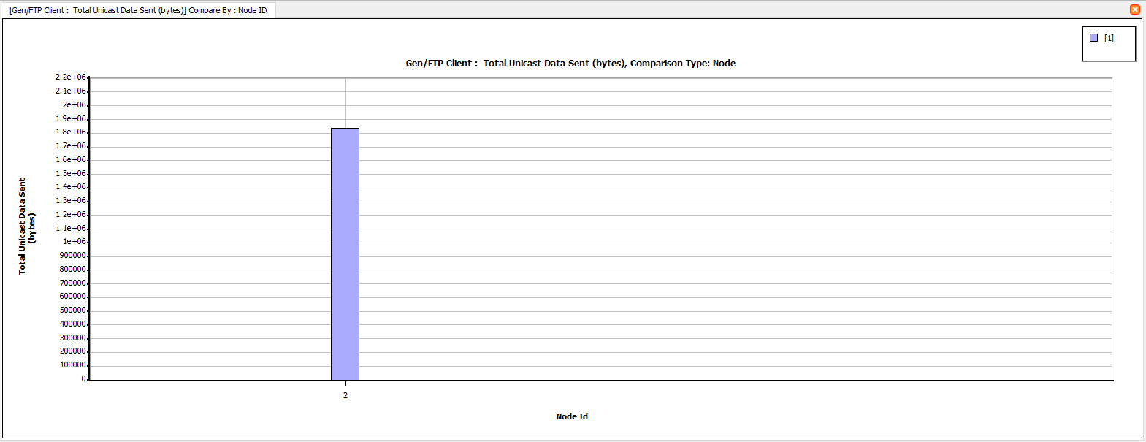

Figure 8. Total bytes sent at TCP

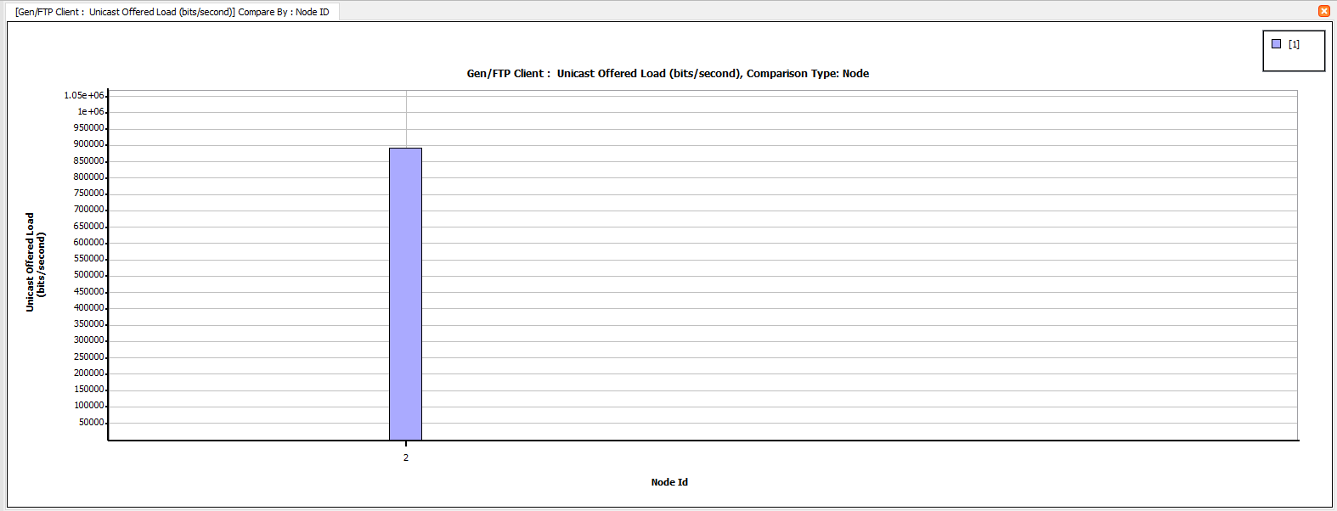

Figure 9. Offered load at TCP

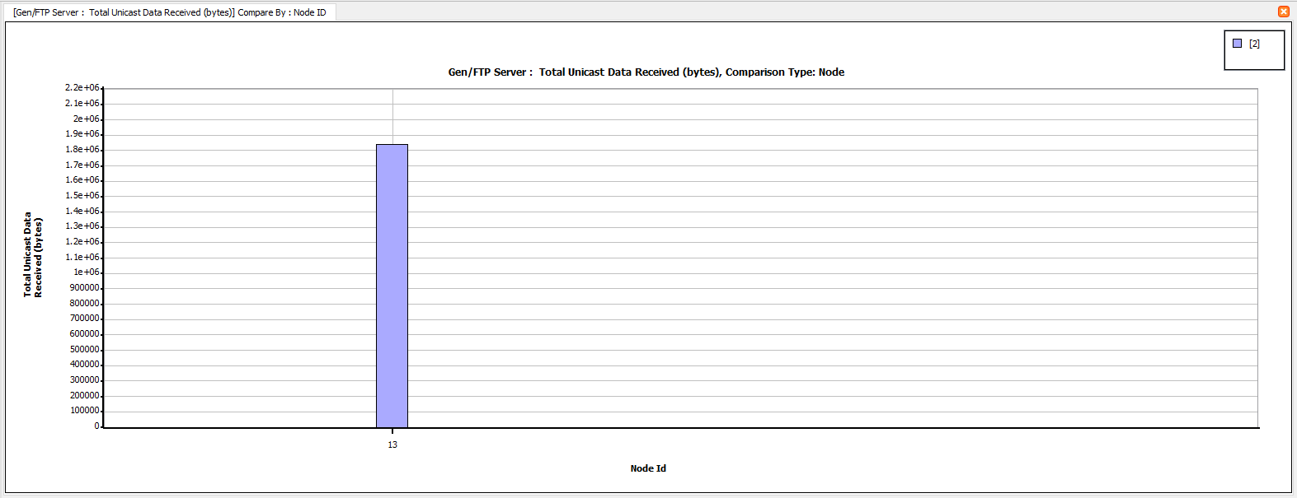

Figure 10. Total bytes received at TCP

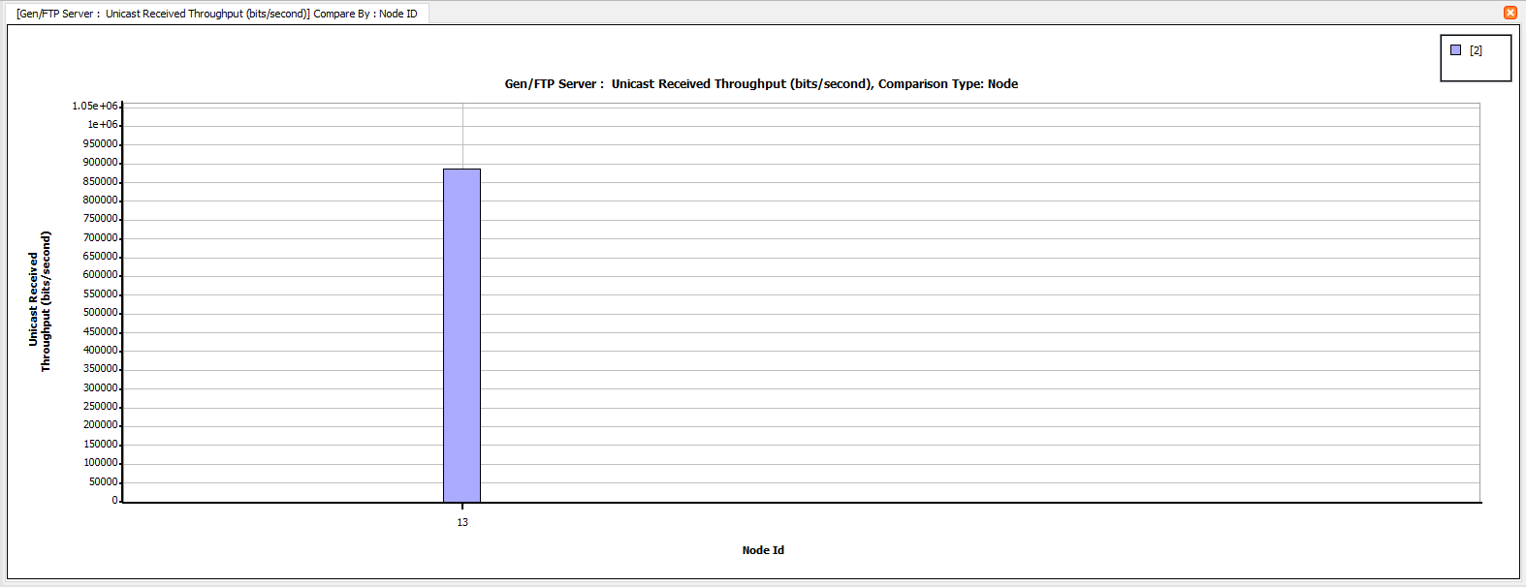

Figure 11. Throughput at TCP

Transport layer:

UDP:

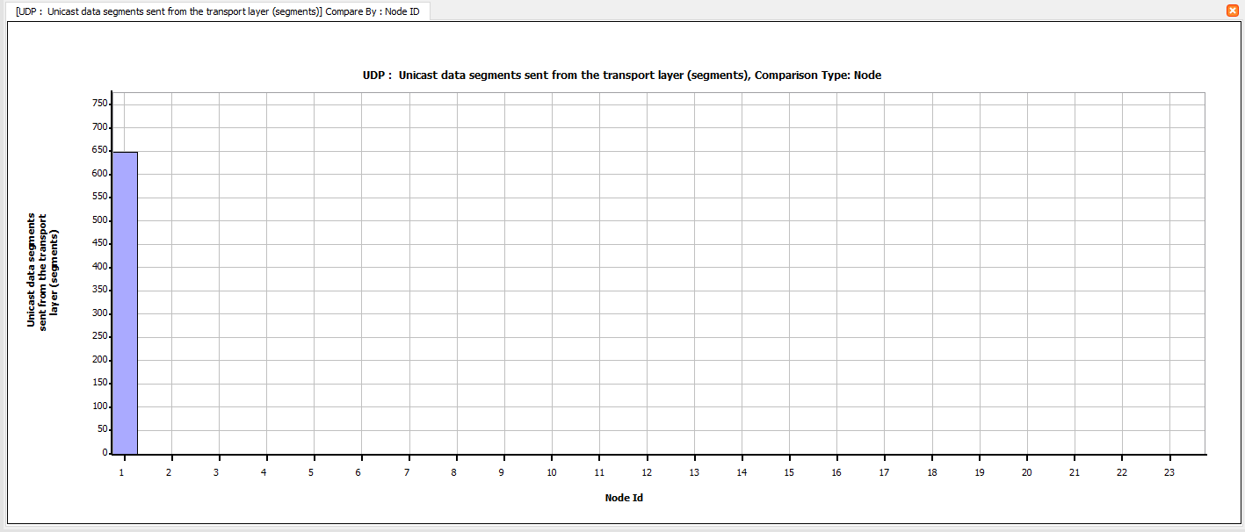

Figure 12. Data Segments sent from the transport layer

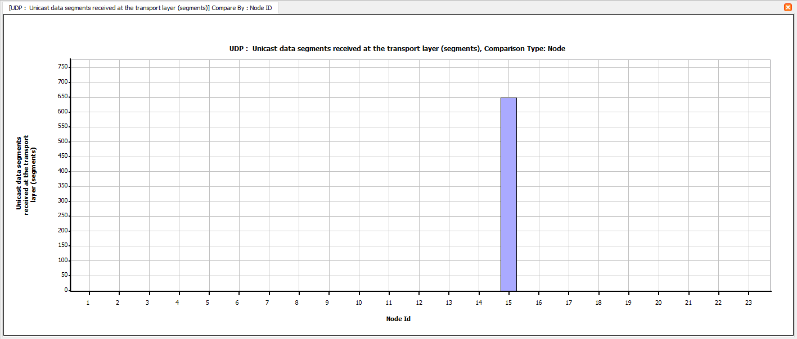

Figure 13. Data segments received at the transport layer

TCP:

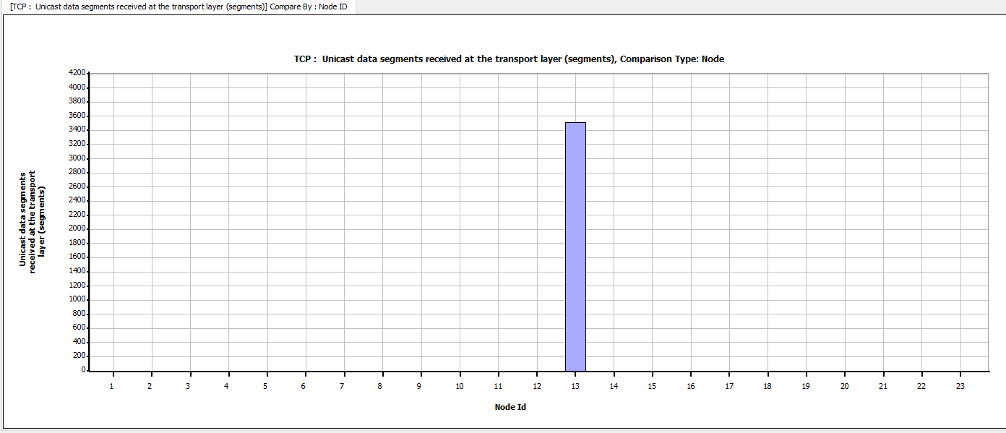

Figure 14. Data packets received at the transport layer

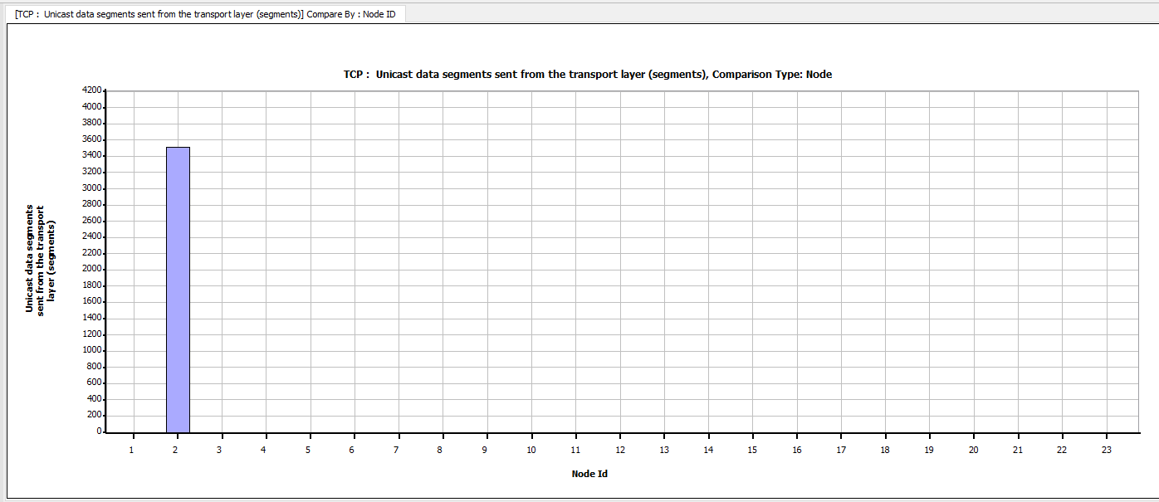

Figure 15. Data packets sent at the transport layer

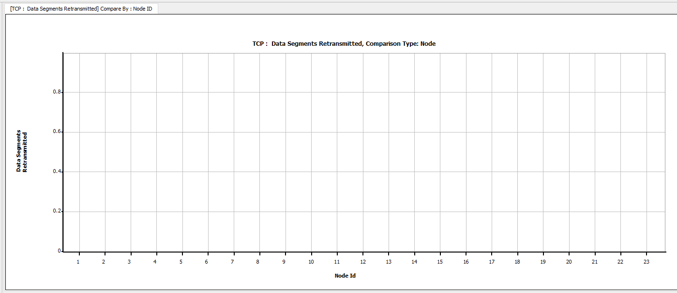

Figure 16. Data packets retransmitted at the transport layer:

MAC layer:

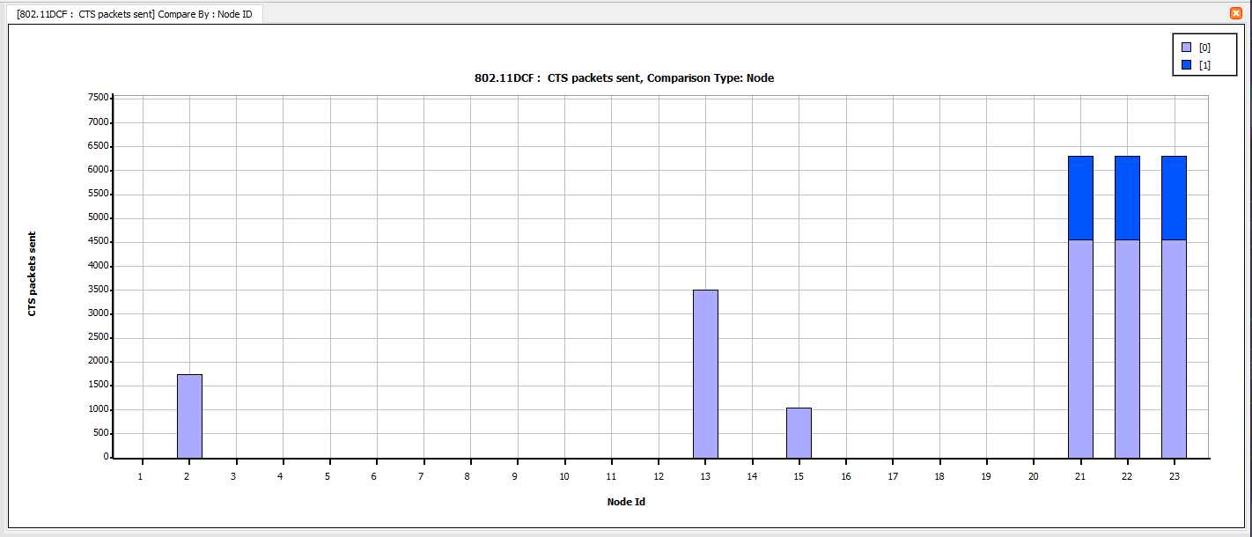

Figure 17. CTS packets sent at the MAC layer

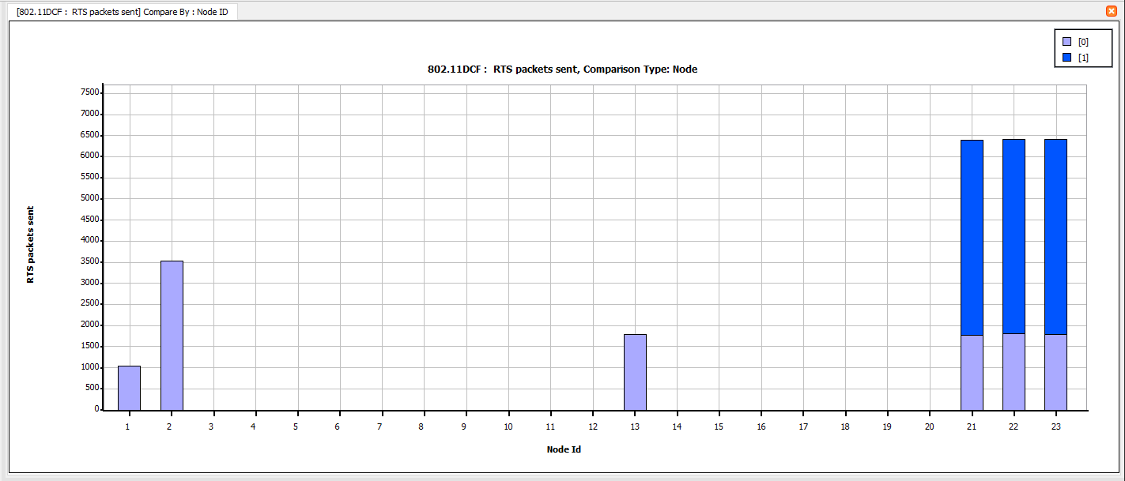

Figure 18. RTS packets sent at MAC layer

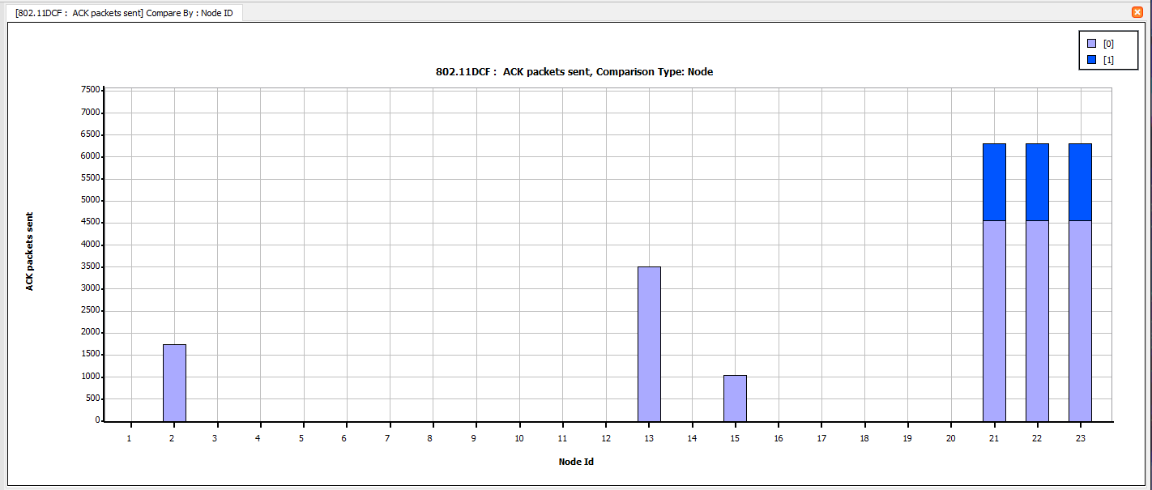

Figure 19. ACK packets sent at the MAC layer

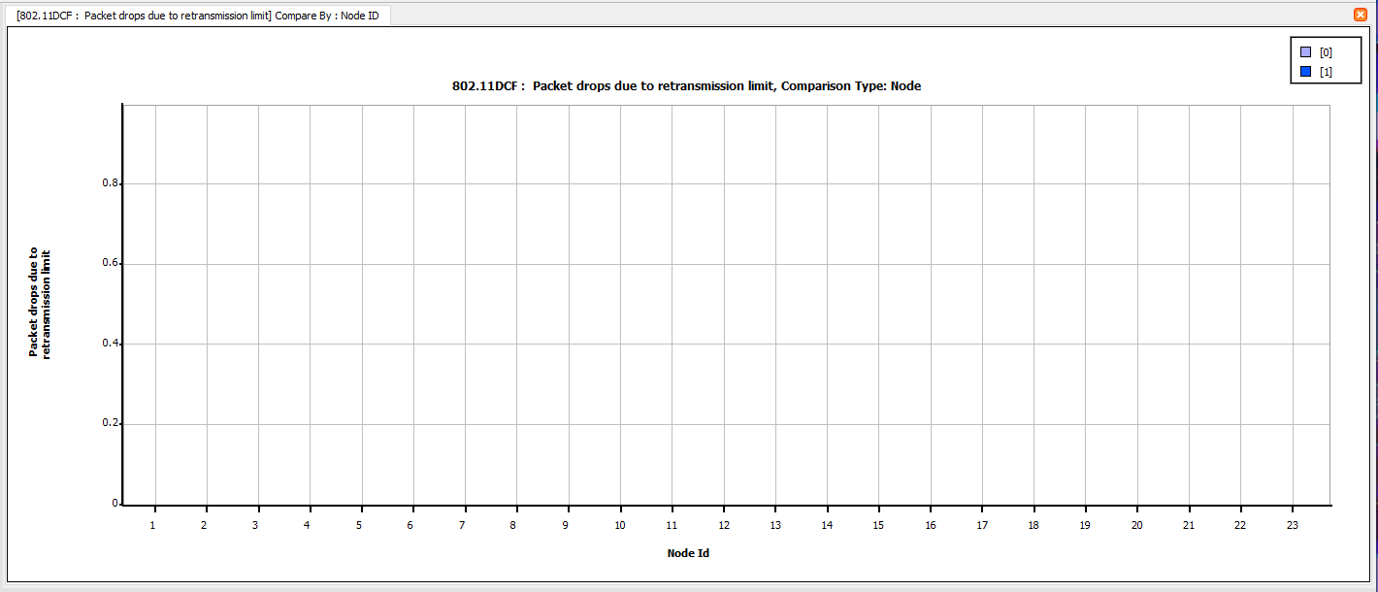

Figure 20. Packets drop due to transmission limit

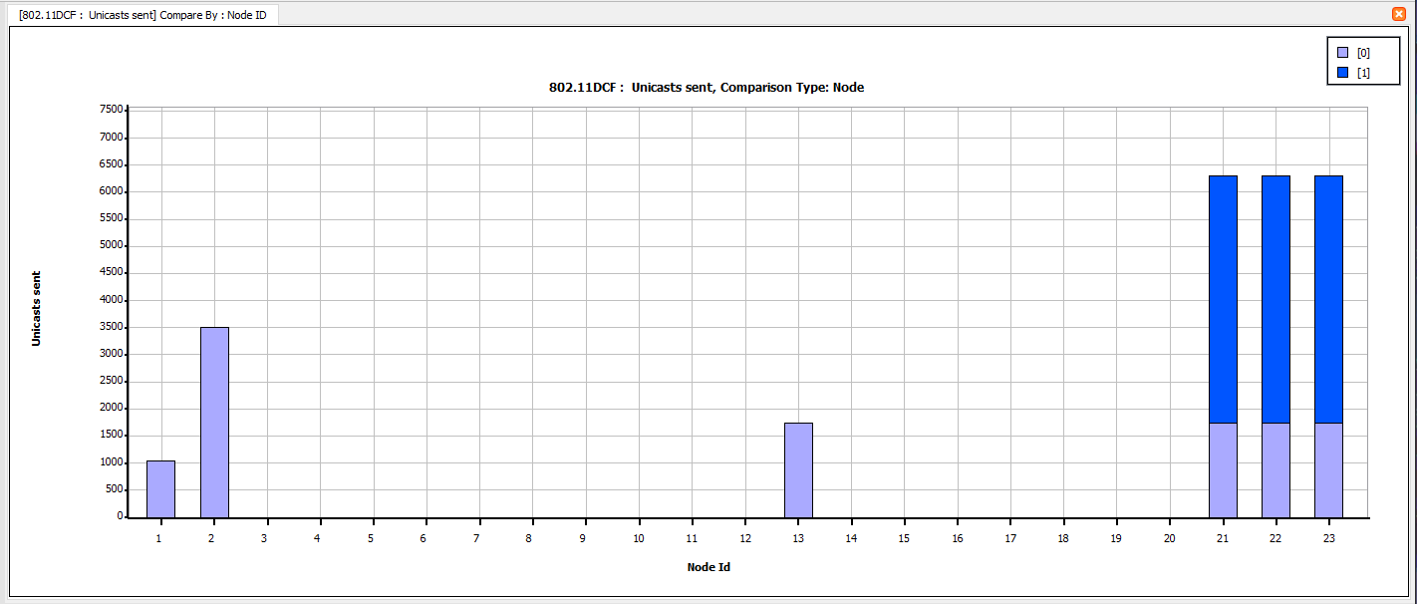

Figure 21. Unicast sent at the MAC layer

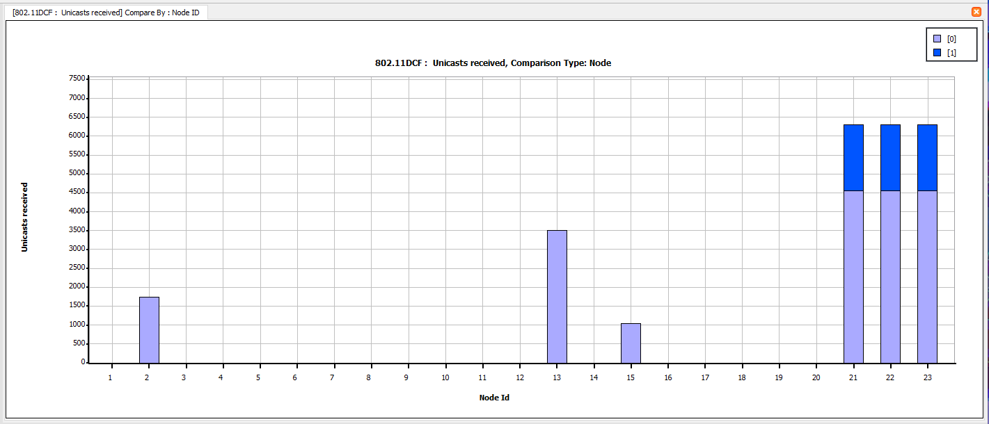

Figure 22. Unicast received at the MAC layer

Tables:

|  |  |  |  |  |  |  |  |
| --- | --- | --- | --- | --- | --- | --- | --- |
| Routers | Interface | RTS sent | CTS sent | ACK sent | Packets retransmitted due to dropout | RTS transmissions due to timeout | Total Unicasts sent (TCP + UDP) packets |
| Router 21 | 0 | 1793 | 4571 | 4571 | 0 | 32 | 1761 |
| Router 21 | 1 | 4634 | 1761 | 1761 | 0 | 63 | 4571 |
| Router 22 | 0 | 1823 | 4571 | 4571 | 0 | 62 | 1761 |
| Router 22 | 1 | 4619 | 1761 | 1761 | 0 | 48 | 4571 |
| Router 23 | 0 | 1810 | 4571 | 4571 | 0 | 49 | 1761 |
| Router 23 | 1 | 4627 | 1761 | 1761 | 4 | 52 | 4571 |

Unicasts sent:

|  |  |  |
| --- | --- | --- |
|  | Interface 1 | Interface 0 |
| Router 1 [21] | 4571 | 1761 |
| Router 2 [22] | 4571 | 1761 |
| Router 3 [23] | 4571 | 1761 |

Unicasts Received:

|  |  |  |
| --- | --- | --- |
|  | Interface 1 | Interface 0 |
| Router 1 [21] | 1761 | 4571 |
| Router 2 [22] | 1761 | 4571 |
| Router 3 [23] | 1761 | 4571 |

From the figure 1 we know that there is a traffic generator (UDP) from Node 2 to Node 13 and an FTP generic (TCP) from Node 1 to Node 15. We observe that unicasts sent at Interface 0 is received at Interface 1 and Unicasts sent Interface 1 is received at Interface 0. This phenomenon is same for all the routers as the UDP and TCP connections follow the same path. The unicasts from router 21 interface 1 to router 22 interface 1 and from router 22 interface 1 to router 23 interface 1 and the same is for interface 0.

The following is verification for unicasts sent:

Total Unicasts sent = RTS packets sent- RTS retransmissions due to timeout- Packets retransmitted due to timeout.

Total Unicasts sent at Interface 1 at router 1 [21] = 4634-63-0=4571

Total Unicasts sent at Interface 1 at router 2 [22] = 4619-48-0=4571

Total Unicasts sent at Interface 1 at router 3 [23] = 4627-52-4=4571

Total Unicasts sent at Interface 0 at router 1 [21] = 1793-32-0=1761

Total Unicasts sent at Interface 0 at router 2 [22] = 1823-62-0=1761

Total Unicasts sent at Interface 0 at router 3 [23] = 1810-49-0=1761

**Scenario B:**

A, B, C and D are the four wireless sub networks that are linked together by the Routing/Forwarding Nodes. The MAC protocol that is used here is IEEE 802.11. The network protocol used here in this scenario is IPv4. In this scenario connections are established between three randomly selected pairs of nodes in the network. We have taken the Rayleigh Fading into account when computing the throughput and the average packet delay. Each sub-network has 5 nodes. From the network schematic we observe that the router 23 is the bottleneck router as it is commonly used by all the traffic generators.

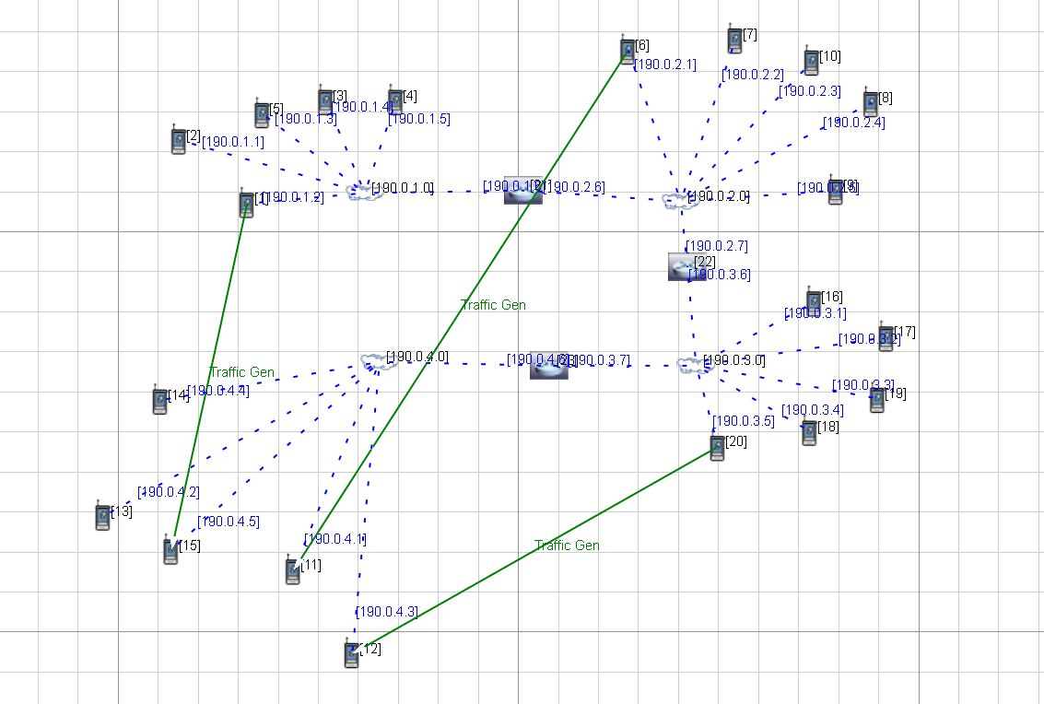

Figure 23. The network diagram for Scenario B

The connections that have been made in this scenario are as follows:

|  |  |
| --- | --- |
| From IP address | To IP address |
| from 190.0.1.2[1] | to 190.0.4.5[15] |
| from 190.0.2.1[6] | to 190.0.4.1[11] |
| from 190.0.3.5[20] | to 190.0.4.3[12] |

Default UDP traffic generator in all connections mentioned above:

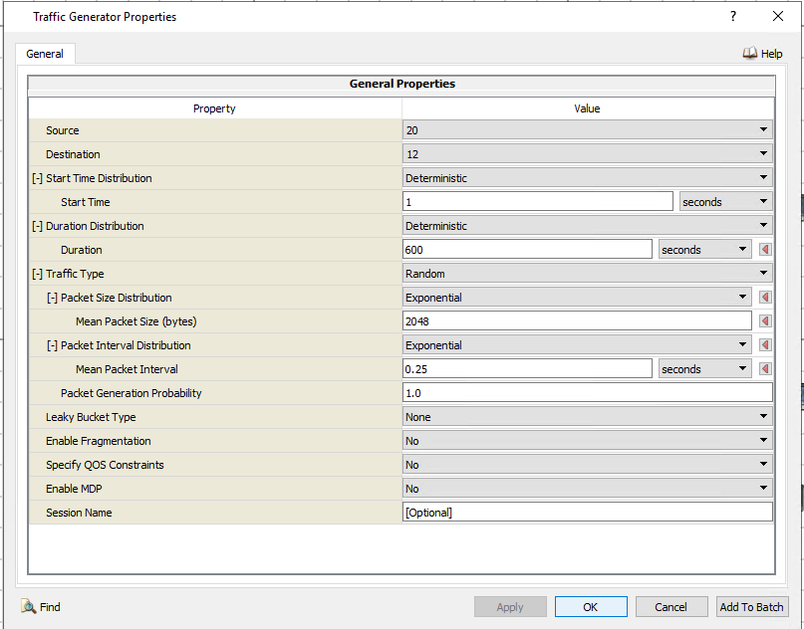

Figure 24

**Result:**

**Without fading:**

For the following calculations we considered the UDP connection between 1 and 15 we varied the mean Packet interval from 0.25 to 1 in terms of 0.10s as shown below.We obtain the following graphs

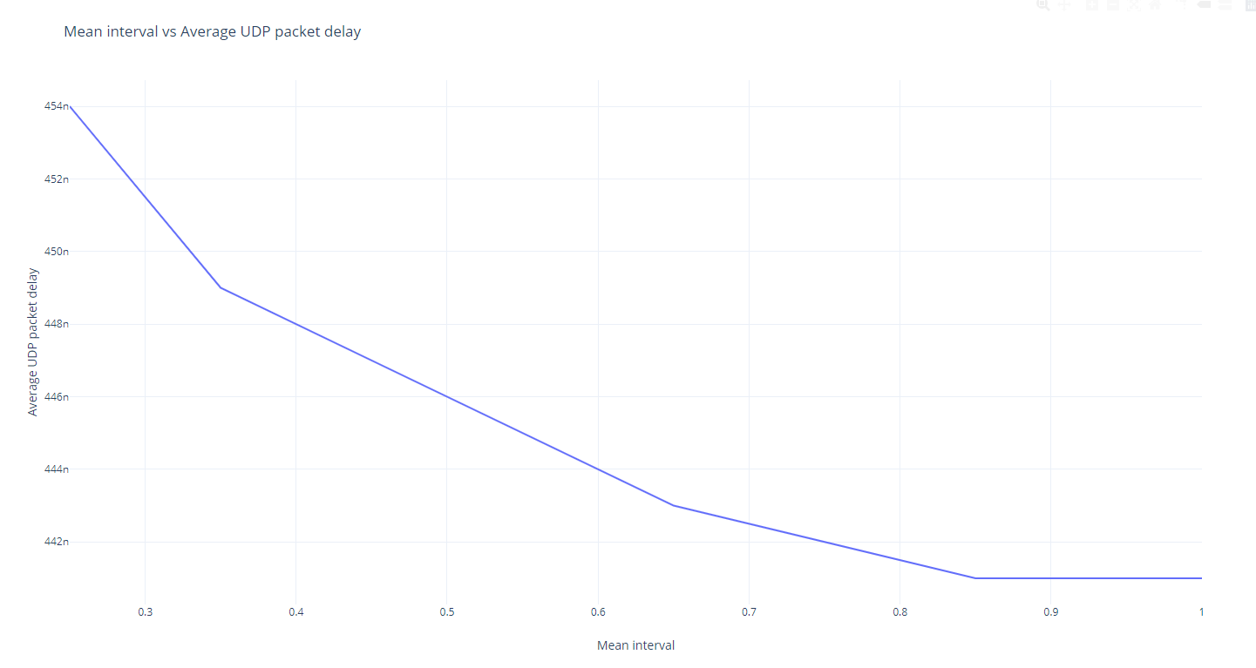

Figure 25. Graph mean interval vs average delay

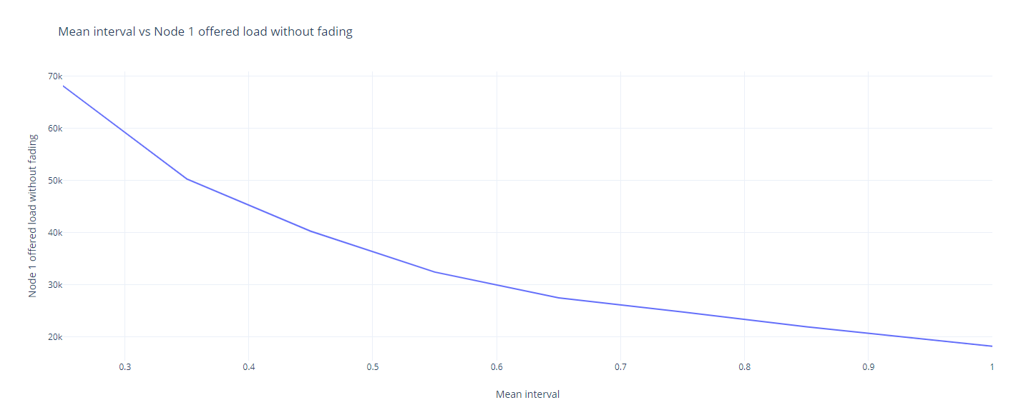

Figure 26. Graph mean interval vs throughput at Node 1

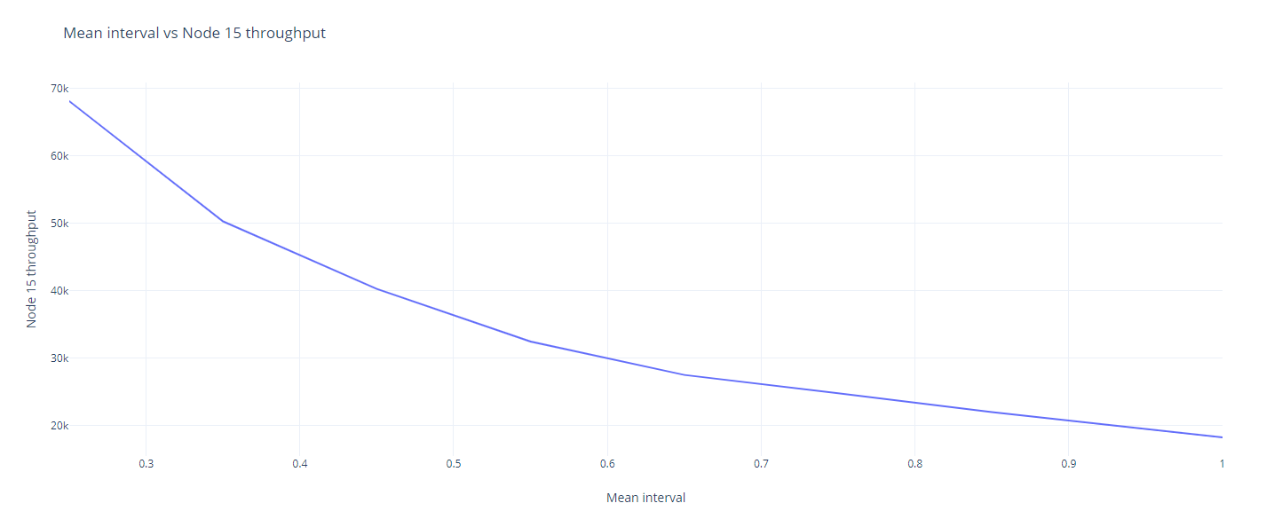

Figure 27. Graph mean interval vs throughput at Node 15

**With Fading:**

For the following calculations we considered the UDP connection between 1 and 15 we varied the mean Packet interval from 0.25 to 1 in terms of 0.10s as shown below. We obtain the following graphs but we include Rayleigh fading in the channels. The fading phenomenon assumes that the reception of data is impacted at nodes.

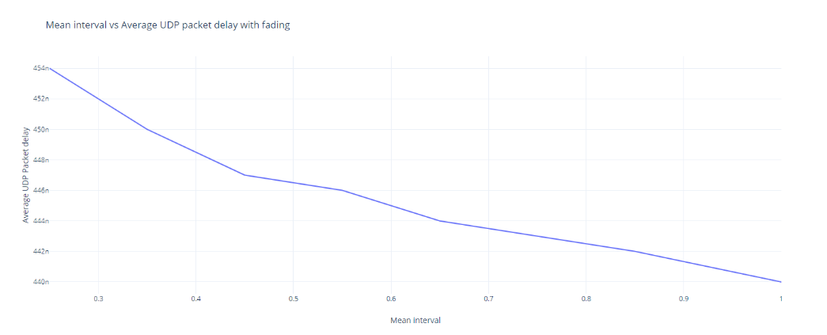

Figure 28. Graph mean interval vs average delay

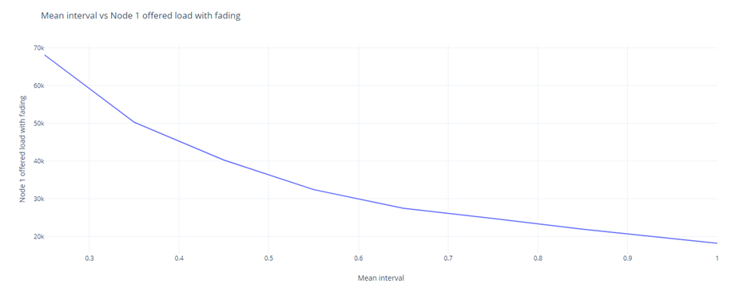

Figure 29. Graph mean interval vs throughput at Node 1

.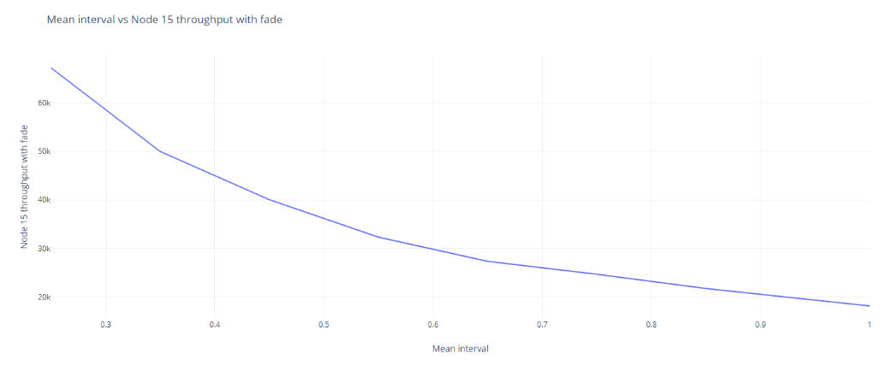

Figure 30. Graph mean interval vs throughput at Node 15

Tables:

|  |  |  |  |  |  |  |
| --- | --- | --- | --- | --- | --- | --- |
| Mean interval | Avg delay without fading | node 15 throughput | node 1 throughput | Avg delay with fading | node 15 throughput  with fading | node 1 throughput  with fading |
| 0.25 | 4.54e-7 | 68089.7 | 68091.9 | 4.54e-7 | 67174.2 | 68091.9 |
| 0.35 | 4.49e-7 | 50264 | 50263.6 | 4.5e-7 | 49942.6 | 50263.6 |
| 0.45 | 4.47e-7 | 40255.5 | 40255.3 | 4.47e-7 | 40024.4 | 40255.3 |
| 0.55 | 4.45e-7 | 32443.4 | 32443.8 | 4.46e-7 | 32300.1 | 32443.8 |
| 0.65 | 4.43e-7 | 27488 | 27488 | 4.44e-7 | 27325.2 | 27488 |
| 0.75 | 4.42e-7 | 24786 | 24786.6 | 4.43e-7 | 24679.1 | 24786.6 |
| 0.85 | 4.41e-7 | 21966.1 | 21966 | 4.42e-7 | 21734.9 | 21966 |
| 1 | 4.41e-7 | 18235.7 | 18235.2 | 4.4e-7 | 18150.4 | 18235.2 |

Conclusion:

From the following trend we understand that as the mean packet interval increases the delay and throughput decrease and we performed the calculations for both with and without fading. From the following trend we understand that the bottle neck router [23] is able to get sufficient time for processing the data and keep its buffers empty for most of the time to receive more data faster hence, there is a decrease in delay if packet interval increases. We also observe the throughput at node 1 remains same for both with and without fading as fading is a phenomenon which is experienced only at the receiver and not at the sender.